

CONTENTS

1. Safety and Warning 3/4
2. Battery Storage 5
3. Usage Condition 5/6
4. Battery Installation 6/7
4.1 Open Box and Check 6
4.2 Notes Before Installation 6
4.3 Install the Wiring 7
5. Battery usage 7/8/9/10
5.1 Three Stage Charging 7/8
5.2 Five Stage charging 8/9
5.3 Discharge 9/10
6. Battery usage Prevention 10/11/12
6.1 Charing prevention 10
6.2 Discharging Prevention 10
6.3 High and Low Temperature Prevention 10/11
6.4 Prevent Short Circuit 11
6.5 Prevent Loose Connections 11
6.6 Prevent exposure to sun 11
6.7 Charger Prevention 11/12
7. Battery Maintenance 12/13
7.1 Basic Maintenance Knowledge 12
7.2 Routine Maintenance Items 13
7.3 Battery Replacement and Recycling 13
8. Common Battery Failures 14/15

1. Safety and Warning

When storing, transporting, installing, using, maintaining and recycling the battery, please operate according to the instructions and abide by the precautions.

Stay away from any fire and heat source.

Please wear protective clothes, glasses and rubber gloves when handling the battery. Please follow the prevention accident protocol.

If acid gets into your eyes, rinse eyes thoroughly with water and go to hospital. If acid gets onto skin or clothes wash with water.

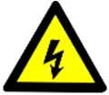
The metal parts of the battery carry an electric charge. Do not place any conductive objects, such as metal tools, on the battery, as this could cause a short circuit. Ensure that the terminal connections are secure to prevent sparks, which could lead to an explosion.

Warning! When the battery is charged, hydrogen and oxygen will be produced. Always check the battery exhaust vent to keep it unobstructed and prevent the battery from exploding due to blockage.
Warning! The usage and storage environment of the battery should be well ventilated to prevent the accumulation of hydrogen and oxygen, and the battery must not be used in an enclosed environment. After charging the battery or operating the vehicle continuously, wait at least 30 minutes before performing any disassembly, installation, or other work on the battery. This allows the hydrogen and oxygen gases generated during use to fully dissipate, reducing the risk of explosion.


The sulfuric acid electrolyte in the battery is highly corrosive. Under normal conditions, it is sealed and should not come into contact with users. However, if the battery is damaged or electrolyte spills due to improper handling, avoid any direct contact.
Keep and use the battery out of reach from children.

The battery should be stored and used upright. Do not turn it or use it on its side or upside down. When transporting the battery should not tilt more than 40 degrees. The battery should not be under heavy pressure and collision to prevent overflow of the sulfuric acid electrolyte on the exhaust hole.

The battery is very heavy, please handle it gently and use suitable handling tools.

Please use and maintain the battery strictly according to the safety warnings and instructions printed on the battery.

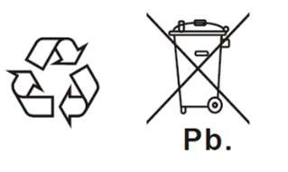
The battery has recycling symbols and should not be thrown away carelessly. Any leaks can harm the environment, so it should be recycled by a proper organization


SAFETY PRECAUTIONS

“Danger” indicates high danger and vigilance; “Warning “indicates moderate danger to on alert; “Caution “indicates mild risk that needs attention.
Danger—Please do not use the battery outside the designated purpose. If it is used outside the designated purpose, it may cause liquid leakage, heating, fire and explosion.
Danger—It is forbidden to disassemble, transform, damage, strongly impact or throw the battery, as it may lead to liquid leakage, heating, fire or explosion.
Danger—It is forbidden to put the battery into fire or heat, as it may lead to fire or explosion.
Danger—It is forbidden to connect the battery in short circuit, otherwise the battery will be heated and ignited.
Warning—If total voltage of battery pack exceeds 45V, safety measures such as insulated gloves shall be used before work. If safety measures are not taken during work, there is risk of electric shock.
Warning—Keep and use the batteries out of the reach of children.
Warning—Sulfuric acid solution is adsorbed on the plates and separators inside the battery. If the battery is mechanically damaged, prevent the sulfuric acid from contacting skin and clothes, and splashing into the eyes. If this happens wash it immediately with plenty of water and go to hospital for serious cases.
Warning—when installing wiring, wrap the handle of metal installation tool with insulating tape.
Notice—It is forbidden to discard batteries at will, as batteries and leakage can pollute the environment.
Notice—It is forbidden to wipe the battery with organic solvents such as petrol or alcohol.
Notice—It is forbidden to store or use the batteries upside down.
Notice—When measuring for maintenance, the face should not be directly on top of the battery and should be kept at an angle or distance.
Notice—The limit temperature range allowed for batteries: Charging 0 to 40°C, discharging -20 to 55°C, storage -15 to 50°C, but use at 20 to 30°C is more conducive to battery life.
Notice—If the battery is used in a way that is not described in this manual, or if there is any inconsistency with other product information, please seek help from your supplier.

2. Battery Storage
High temperatures or poor ventilation during storage and transport can lead to higher self-discharge rate, so keep the battery well-ventilated and keep it away from open flames, sparks, heat sources, organic solvents, etc.
When storing batteries, they should be removed from the charger or load and stored in a dry, cool environment.
As battery storage requires charge maintenance, it is recommended that batteries should not be stored for longer than the following.
6 months below 25°C
3 months 25°C to 35°C
6 weeks above 35°C
If storage exceeds the above time, it should be charged and maintained.
If you are using a charger, the charger setting parameters should follow the charging curves 4.1 and 4.2 until the charger turns green and then continue float charging for 2-4hrs.
If you are using other charging devices, below three charging methods are available.
1) Constant voltage 2.40-2.45V/cell charge 8-12hrs;
2) Constant voltage 2.45-2.48V/cell charge 6-8hrs;
3) Constant current 0.1C(A) Charge for 4-6hrs.
You can also measure open-circuit voltage of the storage battery to determine whether it needs to be charged for maintenance. If open-circuit voltage drops below 2.12V/cell, it is recommended to charge for maintenance.
First in first out management is required during battery storage to avoid battery performance degradation due to a long storage period.
Failure to comply with these storage conditions may result in serious degradation of battery capacity and service life.

3. Usage Condition
Environment temperature range: charge 0 ~ 40°C, discharge -20 ~ 55°C, storage -15 ~ 50°C.
The battery can operate in above temperature range, but the standard data is measured at 25°C. The ideal temperature range for charge and discharge is 20 ~ 30°C for best battery performance and life. Use at lower temperatures will shorten discharge times, while use at higher temperature will shorten life and increase potential for thermal runaway.
Batteries should be kept away from open flames, sparks and heat sources.
Avoid heat and direct sun exposure.
Keep away from water.
The battery will release a small amount of gas in normal use. Avoid enclosed spaces.
Different specifications, different years, different brands, different performance of the battery cannot be mixed, if you need to mix, please contact us for technical guidance.

Notice:
If there is an accidental overcharging, the gas inside the battery will be discharged from the safety valve. Before operating, discharge any static electricity from your body or clothing by touching a grounded surface.

4. Battery Installation

4.1 Open Box and Check
It is recommended to unpack and inspect all individual batteries and accessories at once before installation. This helps check for any damage and prevents items from being overlooked, rather than opening and installing them one by one.
Verify the quantity of batteries and ensure all accessories are included by checking against the attached proposal or packing list.
Batteries are heavy and should be handled or installed with special care. Avoid battery case damage from collision, drop or impact. In absence of battery handle, the battery should be lifted from the bottom of the battery.
The insulating terminal cover protects the battery terminals during transportation. It should be removed before installation.

4.2 Notes before Installation
Before making any connections, check the battery to ensure the terminal polarity is correct. Verify the configuration number and install the batteries in their designated groups. Do not mix them up.Polish the battery terminals so that they have a metallic shine.
Check all connection cables to make sure they are clean and free from damage.
To prevent electric shock or short circuits, insulate all metal tools (e.g., wrenches) by wrapping them with insulating tape. Wear insulated gloves and remove any metal objects such as watches, bracelets, or rings before working.
When connecting terminals, ensure that they are securely connected. Tighten each bolt or nut, but do not use too much force to avoid damage.
For the damaged terminal seal structure, see Table 1 for the recommended tightening torque.

Table 1: Tightening torque recommendation table
Bolt Specification | M5 | M6 | M8
Tightening Torque | 2.0～3.0N·m | 3.9～5.4N·m | 11～14.7N·m

Notice:
Loose terminal connections can cause unstable battery performance, damage the battery, or pose a safety risk.
Avoid installing the battery near heat sources (e.g. transformers) or in front of cooling fan exhausts from other equipment.
The battery should not be installed near devices that generate sparks (e.g. fuses).

4.3 Install the Wiring
Install the battery upright, not upside down.
To ensure good heat dissipation, keep space between batteries at least 20mm, heat dissipation holes should be installed around the battery box.
The installation should include vibration and pressure protection and be secure to prevent the battery from moving, bumping, or rubbing against other parts during use.
The battery box should not be completely sealed. The air hole should not be smaller than 10mm and should not be blocked.
When multiple batteries are used together, connect the batteries first, and then connect the battery pack with the charger or load. Note that the positive terminal of the battery pack should be connected with the positive terminal of the charger or load, and the negative terminal should be connected with the negative terminal.
Note: If the battery is not properly connected to the charger or load motor, the charger or load motor may burn out.
The power test can be performed only after the battery is installed and the total voltage of the battery string is correctly measured.

5. Battery usage

5.1 Three Stage Charging
The charger automatically switches between the three stages of charging.
The first stage (S1), constant current charging, charges at a constant current of 0.15-0.18C. The charger will automatically switch to the second stage when single cell voltage reaches 2.40-2.45V.
The second stage (S2) is constant voltage charging, where each cell is charged at a constant voltage of 2.40–2.45V. When the charging current drops to between 0.012C and 0.02C, the charger will automatically switch to the third stage. At this point, the charger’s indicator light usually turns green, indicating the battery is fully charged.
The third stage (S3) is float charging, where each cell is maintained at a voltage of 2.28–2.32V. Float charging lasts for 2 to 4 hours, after which the charging should be stopped by turning off the charger.

◆ Charging Time Recommendation:

1) Charge above 25°C for about 12hrs. If surface temperature of the battery reach 45°C, stop charging until the temperature drops below 30°C and charging can be continued, otherwise, the battery will get damaged.
2) Charging below 25°C, the battery is stored indoors for 1hr and then charged for about 16hrs.
The charger should have charging temperature compensation function, with 25°C as the base point, for every 1°C increase in ambient temperature, the
charging voltage will be adjusted down by 4mV/cell. For 1°C decrease in ambient temperature, the charging voltage will be adjusted up by 4mV/cell.

Fig. 1: Three-stage charging curve

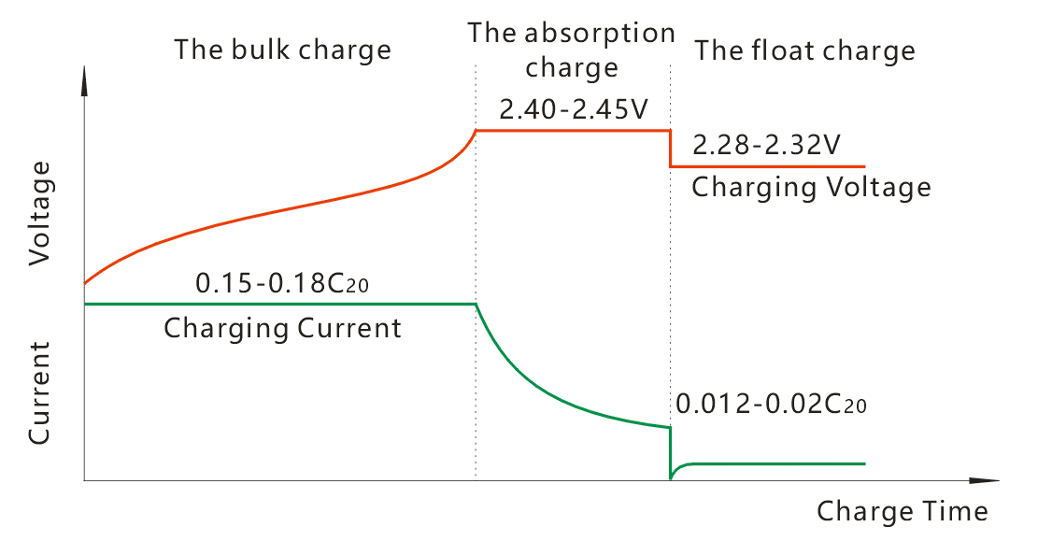
Notice：
In different voltage systems, the current remains the same, but the voltage varies. For example:
- During constant voltage charging:
  - 48V system voltage is 57.6–58.8V
  - 24V system voltage is 28.8–29.4V
- During float charging:
  - 48V system voltage is 54.7–55.6V
  - 24V system voltage is 27.4–27.8V

5.2 Five Stage Charging
The first stage (S1), charging at constant current of 0.18-0.2C, automatically switches to the second stage when single cell voltage reach 2.40V.
The second stage (S2), charging at constant current of 0.10-0.12C, automatically switches to the third stage when single cell voltage reach 2.47V.
The third stage (S3), charging at constant voltage of 2.47V with current limit of 0.05C, automatically switches to the fourth stage when charging current drops to 0.01C.
The fourth stage (S4), charging at 0.01C constant current, when the voltage of single cell reaches 2.50V, it automatically switches to the fifth stage, at which point the charger should turn the light green which means it is fully charged.
The fifth stage (S5), single cell voltage 2.3V floating charge, floating charge 2-4hrs can end the charge, at this time the charger should be turn off.

◆ Charging Time Recommendation:
The charging time under the five stage charging curve is for reference, but the charging time of the five stage charging method shall not be less than 12hrs.

Fig. 2: Five-stage charging curve
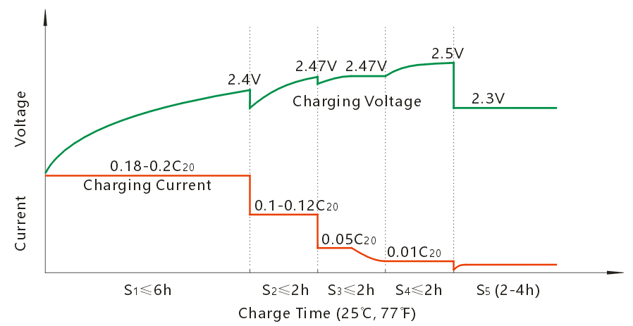
Notice:
In different voltage systems, the current is constant, but voltage should vary. For example, in 48V system, the current should be constant, but voltage should vary as follows: the first stage voltage should be 57.6V, the second and third stage voltage should be 59.3V, the fourth stage voltage should be 60V, and the fifth stage floating charge voltage should be 55.2V.

5.3 Discharge
When the load is operating, the battery is in the discharge stage and over-discharge is strictly prohibited.
To avoid battery over discharge, single-cell protection voltage is 1.75V, 6V battery is 5.25V, 8V battery is 7V, and 12V battery is 10.5V.

See Table 2 for the protection voltage under different voltage systems.

Table 2: Battery power-off protection voltage
Voltage System | 2V/Cell | 24V System | 48VSystem
Power-off protection voltage (V) | 1.75V | 21V | 42V

Notice:
If the battery is used in a vehicle, avoid frequent high-current starts. High current discharge can delay the positive plate’s active materials from fully participating in the chemical reaction, causing repeated expansion and contraction. Over time, this leads to the softening and shedding of these active materials, which reduces battery life.
Frequent large current discharge accelerates the softening and shedding of the positive plate’s active material inside the battery, which ultimately reduces battery capacity and shortens its lifespan.
Therefore, during daily use, avoid discharging large currents. When starting the vehicle, press the accelerator pedal gradually until the vehicle reaches a steady speed.
It is suggested that the starting current should be less than 1.5C. Uniform running current should be less than 0.5C.
The connection wire should be chosen based on the vehicle’s continuous climbing current or maximum operating current. If the wire diameter is too small, it can overheat during use, potentially damaging the battery or causing a fire.

6. Battery usage Prevention

6.1 Charging Prevention
The quality of battery charging performance plays an important role in battery life and service performance, which must be payed attention to.
Charging is the reverse of the battery’s electrochemical discharge process. In an ideal state, the charging reaction is fully reversible, meaning the amount of electricity put into the battery during charging is nearly equal to the amount released during discharge.
1) If the charging settings are incorrect or the charger is not suitable, a high voltage, excessive current, or overly long charging time can cause increased water loss in the battery. For AGM batteries, excessive gas buildup can damage the battery and lead to premature failure.
① The large amount of gas produced can erode the active material on the electrode plate, causing it to easily break off.
② At higher polarization voltages, the positive plate’s grid undergoes severe corrosion, leading to deformation, brittle cracks, and loss of structural support and conductivity. This shortens the battery’s lifespan.
2) If the battery is undercharged for a long time, unreacted active material will form irreversible coarse lead sulphate crystals, known as sulfation. This reduces battery capacity, increases internal resistance, makes charging more difficult, and can cause the battery to fail prematurely.
Therefore, the battery should be fully charged to prevent irreversible sulfation.

6.2 Discharge Prevention
The battery protection voltage is set at 1.75V per unit. When the power meter indicates low voltage or there is a power failure while using the vehicle, do not rely on the battery’s rebound voltage to continue driving. This rebound voltage is false and continuing to use the battery at this stage will cause over-discharge. Excessive deep discharge damages the positive plate’s active material, increases corrosion, and ultimately reduces battery capacity and lifespan.
Therefore, the battery should be charged before the vehicle’s low voltage alarm activates or replaced at the recharging station. Any replaced battery should be charged promptly, as leaving it unused for a long time can also reduce its capacity.

6.3 High and Low Temperature Prevention
When batteries are operated in high temperature seasons, there is risk of overcharging.
As battery temperature rises, the activity of the active materials increases. This lowers the oxygen evolution potential at the positive electrode and the hydrogen evolution potential at the negative electrode. As a result, the battery can accept charge more easily, charging reactions speed up, and the charging current increases, requiring a lower voltage to fully charge the battery. To prevent excessively high charging voltage, the battery temperature should be kept low with proper heat dissipation.

Keep away from heat sources, do not charge under the sun, and avoid charging immediately after sun exposure.
In low-temperature environments, the battery’s active materials become less reactive. This reduces the positive electrode’s ability to accept charge, while swelling at the negative electrode further lowers its charging capacity, making the overall charging acceptance much lower in cold conditions.
Therefore, charging at low temperatures causes poor charge acceptance and incomplete charging, requiring higher charging voltage and longer charging time. To improve charging, the battery should be placed in a warm environment—as described in section 4.1—and kept indoors for at least 1 hour before charging. This helps ensure a full charge, prevents irreversible sulfation, and extends battery life.

6.4 Prevent Short Circuit
Therefore, the connection Under battery short circuit state, its short circuit current can reach thousands of amperes. part will produce a lot of heat when short-circuiting, which will fuse the connection, damage surrounding sealants or shells, and cause hidden dangers like leakage.
Therefore, to prevent short circuits, handle the battery with care during installation and use. Always insulate all tools, and when connecting wires, first attach them to the external device. After confirming there is no short circuit, connect the wires to the battery last.
Battery terminal screws should be covered with matching insulation sleeves or take other insulation measures.
Wiring specifications should be well insulated to prevent overlapping compression and rupture.

6.5 Prevent Loose Connections
If the terminal is not securely connected to the connection strip, even slightly, it can cause poor conductivity. This leads to overheating at the contact point, increased wire resistance, lower output voltage, and reduced motor performance, which may decrease the vehicle’s range or prevent it from operating properly.
If the terminal parts are not properly connected (which is a common source of faults), excessive heat can be generated at the terminals, damaging the connection and sealant. If this continues over time, it can cause terminal leakage. During driving or charging, a loose connection may also cause sparks, leading to safety hazards.
Electric vehicles have to bear strong vibrations during operation. Therefore, all connections should be reliable to ensure that no accidents occur during driving.

6.6 Prevent Exposure to the sun
Exposure to sunlight raises the battery’s temperature and internal pressure, which can cause the safety valve to open. This increases water loss and lowers the battery’s gas evolution potential, ultimately shortening its lifespan. Charging the battery in direct sunlight should also be avoided.

6.7 Charger Prevention
The charger control must be accurate to have a stable voltage and current, otherwise it will damage the battery. The following are examples of battery damage caused by chargers.
1) If output voltage or output maximum current is too low, it will shorten the life of the battery. If used for a long period of time, it can lead to sulfation of the pole plates and reduction in battery capacity.
2) If output voltage of charger is too high, it will cause the battery to overcharge and lose water, which will lead to reduction in capacity, shortened battery life, and may even bulge or become deformed.
3) If the charger’s rectification is poor and the ripple coefficient exceeds 2%, it can cause battery self-discharge, excessive heating during charging, and even battery bulging.
4) If there are short circuit issues inside the charger, ike a short circuit at the output, or damaged/missing diodes that normally stop electricity from flowing backward, the charger won’t be able to charge the battery properly. As a result, the battery can become deeply discharged repeatedly, which will damage it and eventually ruin its lifespan.
5) If the charger is unstable it will lead to battery damage.
6) The battery should be charged promptly after discharge; otherwise, sulfation may occur, reducing its capacity.
7) The charger designed for flooded batteries uses a higher charging voltage. If you use this charger to charge an AGM battery (which requires a lower voltage), it can cause the AGM battery to overcharge and swell, potentially damaging it.

7. Battery Maintenance

7.1 Basic Maintenance Knowledge
Battery life depends not only on the quality of the battery and the electric vehicle’s system, but also largely on how the user operates and maintains it. Therefore, it is important to understand some basic battery maintenance principles.
1) The battery should never be stored when fully discharged. If left unused for several days before recharging, the plates are likely to develop irreversible sulfation, reducing capacity. Storing a battery in a discharged state severely shortens its lifespan. The longer it remains idle, the greater the damage.
2) If a new electric car’s initial range is 60 km but drops significantly within three months (such as falling below 30 km) you should use a multimeter to check the voltage of each individual battery cell. Typically, a fully charged cell measures about 6.55V for a 6V battery, 8.73V for an 8V battery, and 13.1V for a 12V battery. If one battery’s voltage is noticeably lower than the others, it may have an internal short circuit and needs to be replaced to prevent damage to the rest of the batteries. At the same time, the charger’s charging parameters should also be checked to ensure they are correct.
3) Check the battery connection cable once a week. The driving vibration of vehicle may cause a loose bolt or nut of the connection cable. It needs to be checked regularly. If loosened bolt or nut is found, fasten it immediately.
4) When starting the electric vehicle, gently press the accelerator pedal to begin moving with a small current until the vehicle reaches a steady speed. Once the vehicle is moving, you can press the accelerator pedal fully for more power. However, pressing the pedal all the way down causes the motor current to increase quickly, which drains the battery faster and causes the voltage to drop rapidly. Since shallower battery discharges help extend battery life, reducing high current draw during acceleration can prolong the battery’s lifespan and increase the vehicle’s driving range.
5) In winter, it’s normal for the battery capacity to drop as the temperature goes down. Using 25°C as the standard, the battery capacity is about 85% when the temperature is 0°C.
6) Use a charger that matches the battery model. During charging, avoid high temperatures and humid environments. Keep water away from the charger to prevent short circuits. The charger should have a temperature compensation feature. Based on a standard temperature of 25°C, the charging voltage should decrease by 4 mV per cell for every 1°C increase in ambient temperature. Similarly, for every 1°C decrease in temperature, the charging voltage should increase by 4 mV per cell.
7) Keep the battery surface clean at all times. Park the vehicle in a cool, dry, and well-ventilated area.
8) If the vehicle will be stored for a long period, make sure the battery is fully charged beforehand. Recharge the battery at least once a month during storage. Alternatively, under the guidance of a professional, you can disconnect one of the battery pack’s cables to put the battery in an open (disconnected) state, which allows for longer storage. For charging instructions during storage, refer to section "1. Battery Storage."

7.2 Routine Maintenance Items

Item | Frequency | Check | Standard | Maintenance
Battery single cell voltage | One month | Measure the voltage of each cell with a multimeter after a full charge | Voltage difference should be:  - 6V battery: less than 0.2V  - 8V battery: less than 0.3V  - 12V battery: less than 0.4V | Charge any underperforming cell separately. If voltage still falls outside the standard, replace the faulty cell.
Battery appearance | One month | Visually check battery case and cover for acid leakage, deformation, cracks or damage | No visible damage or abnormalities | If damage is found, determine the cause. If it affects performance, replace the battery.
Battery appearance | One month | Visually check the battery surface for dust and stains | Appearance is clean | Clean the dust and stains on the battery surface with a dry cloth
Battery appearance | One month | Visually check whether there is rust or corrosion in the connector or terminal | No rust, no corrosion | Slight rust or corrosion, use a steel brush to remove rust, and apply rust inhibitor. For severe rust or corrosion, replace with a new connector or battery
Connector | One week | Use wrench to check whether the bolts and nuts are loose | Strong connection | Tighten immediately if it gets loose

Notice：
Removing or replacing the battery, as well as removing rust from connectors or terminals, should only be done by trained professionals. Attempting these tasks yourself may be dangerous. Please contact the supplier or authorized service personnel for maintenance.

7.3 Battery replacement and recycling
Batteries are consumable items with a limited lifespan. Over time and through repeated charging and discharging, their capacity will gradually decrease, resulting in shorter driving range for the electric vehicle.
If the battery capacity drops below 50% of its rated (nominal) value during the warranty period, it is considered faulty. In this case, please contact the supplier for support. If the battery is out of warranty and its capacity falls below 50%, it's recommended to replace it with a new one.
The battery is marked with a recycling symbol. Used or damaged batteries should be recycled through certified recycling organizations or returned to the supplier for proper disposal. Do not throw batteries in the trash or discard them improperly, as this can cause environmental pollution.

8. Common Battery Failures
1) Battery Leakage
a. Check whether the seal between the cover and the bottom slot is cracked due to poor sealing or collision, resulting in battery leakage.
b. Check whether the safety valve leaks acid.
c. Check whether there is acid leakage outside the terminal.
d. Check whether the battery case is cracked, damaged or leaking.
The leaking battery cannot be used and should be replaced with a qualified battery. If you cannot determine, please seek supplier for help.
2) Charging Heat
a. The battery heats up during the charging process. Check the charging voltage and current of the charger. If the voltage is too high or the current is too high, the temperature of the battery will rise during the charging process and may even swell.
b. Check whether the battery connector is firmly connected with the terminal. Poor connection may also cause the battery to overheat and burn out the terminal or connector during the charging process.
If the cause of the overheating is found and the temperature of the battery does not exceed 50°C, wait until the temperature of the battery is lower than 30 °C, and there is no potential for heating problem, you can continue use the battery.
If the cause of heating is not found, seek help from the supplier.
If temperature of the battery exceeds 50°C or the battery is swollen and deformed, it cannot be used anymore and should be replaced with a qualified battery.
3) Battery Short Circuit
If a single cell inside the battery develops a short circuit, the battery’s open-circuit voltage will be about 2V lower than normal. During charging, this issue may cause a strong reaction, such as noticeable heat in the affected cell.
If the short-circuited battery cannot be used any longer, it should be replaced by a qualified battery.
4) Battery Open Circuit
a. If the battery pack has voltage but cannot be charged or discharged, it may contain a single cell with an open circuit. You can use an internal resistance meter to identify the faulty cell, as an open-circuit battery will show a very high internal resistance.
b. Open circuit state: If the battery has no voltage, it has an open circuit.
The open circuit battery cannot be used any longer, it should be replaced with a qualified battery.
5) Irreversible sulfation
a. When the plate is severely sulfated, the voltage rises quickly, the gas precipitates prematurely, and the temperature rises quickly.
b. The battery discharges quickly until it reaches its cutoff (final) voltage, resulting in reduced capacity.
c. Upon disassembly, the positive and negative plates were found to be hard and brittle. The separator was stuck to the plates, and white crystals were visible on the surface.
Check if the battery has been left undercharged for a long time or stored with a low charge.
Batteries with slight sulfation can recover during normal use. However, severely sulfated batteries experience a significant drop in capacity and can no longer be used. In such cases, they should be replaced with new, qualified batteries.
6) Single Battery Capacity is low
Within the same battery pack, if one cell’s voltage drops faster than the others and quickly falls to the protective voltage level (1.75V per cell), that cell is considered weak or faulty.
For maintenance of a weak cell, refer to section 7.2.

Notice：If the faults found are not included in the above, please seek help from the supplier.

-END-

Contact us Via:
Tel: +44 01673 844814
Email: batterysupport@equipglobalsupplies.com
Website: www.equipglobalsupplies.com

